
MATHEMATICS DEPARTMENT
Year 11 Specialist – 2016
Test Number 4:
Combinations and Circle Geometry
Resource Rich

Name: _______________________________________ Teacher: DDA
Marks: 47
Time Allowed: 45 minutes
Weight: 7%
Instructions: You are permitted 1 A4 page of notes and your calculators. Show your working where appropriate remembering you must show working for questions worth more than 2 marks.
_________________________________________________________________________
Part A
5 multiple choice questions
5 marks
1 Counting the 1 at the top as row 0, what is the fifth number on row 9 of Pascal’s triangle?
A 126
B 70
C 56
D 120
E 210

[1 mark]

2 In the diagram, O is the centre of the circle. The value of ∠ACB is:
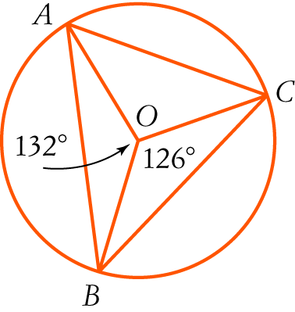

A 24°
B 27°
C 66°
D 63°
E 39°

[1 mark]
3 The size of ∠VTU in the diagram is:
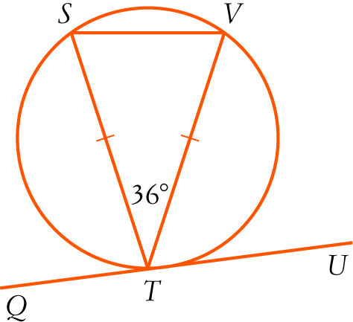

A 72°
B 54°
C 36°
D 18°
E 90°

[1 mark]

4 The value of x in the diagram is:
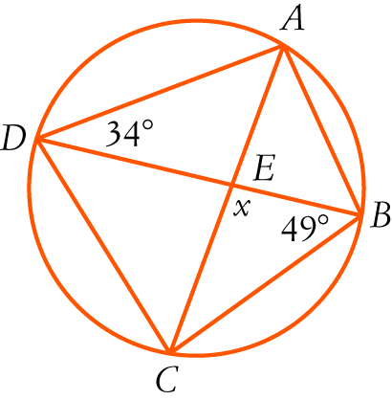

A 83°
B 68°
C 98°
D 96°
E 97°
[1 mark]
5 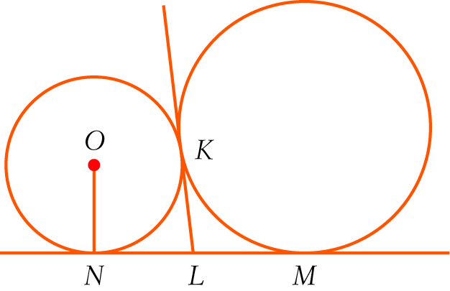
In the diagram, NM is a common tangent to the circles. KL is also a common tangent and O is the centre of the smaller circle.
Consider the statements:
I LN = NO II KL = LN III LN = LM
Which of the statements are true?
A I and II
B I, II and III
C II and III
D I and III
E None of the above.

[1 mark]

Part B
8 short answer questions
32 marks
Show your working where appropriate.
6 nC6 = 7 × nC4. Solve for n.

[5 mark]
7 There is only one black jelly bean in a packet with 20 left in it.
a How many different selections of 6 jelly beans are possible?

b How many selections include the black one?

[4 marks]

8 A class has 24 students. Of these students, 9 do not do any of Physics, Chemistry or Computer Science. There are 6 who do Physics and Chemistry, 4 who do Physics and Computer Science and 5 who do Chemistry and Computer Science. There are 11 Computer Science students, 8 who do Physics and 8 who do Chemistry. Use the inclusion-exclusion principle to find how many do all three of Physics, Chemistry and Computer Science?

[5 marks]
9 What is the probability of getting exactly 2 faulty switches if you take 5 switches from a box of
12 switches with 4 faulty ones in it?

[3 marks]

10 In the diagram, DF = 6 cm and OE = 4 cm.
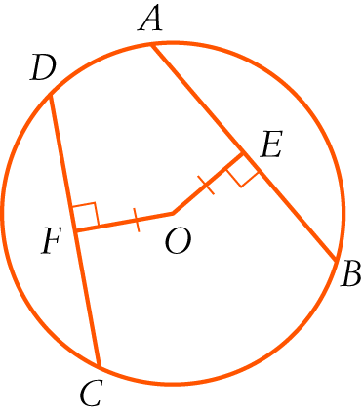
a Find the length of AB giving reasons.

b Find the radius of the circle in exact form.

[5 marks]
11 Find the value of x in surd form, giving reasons.
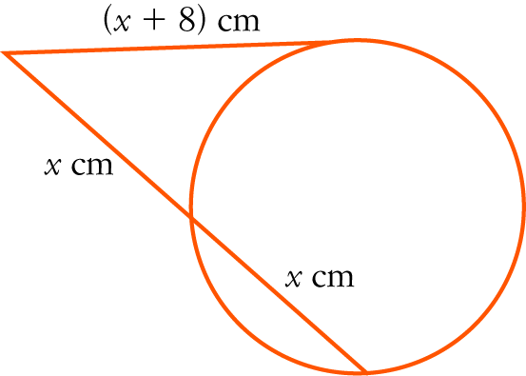

[4 marks]

12 In the diagram, AB is a diameter of the larger circle with centre C and A is the centre of the smaller circle.
The circles intersect at D. Explain why BD is a tangent to the smaller circle.
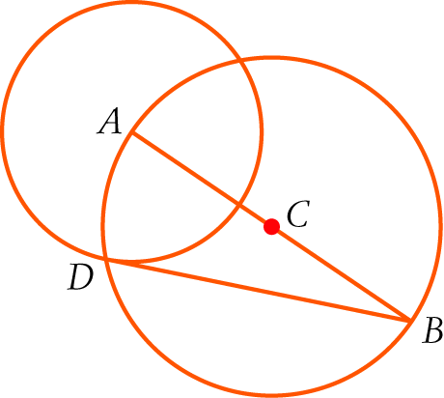

[3 marks]
13 Find the value of x, giving reasons.
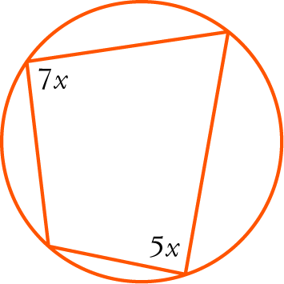

[3 marks]

Part C
2 analysis questions, 10 marks. Show your working where appropriate.
14 The ninth number of a row of Pascal’s triangle is half of the eighth number in the row. What is next (tenth) number in the row?

[5 marks]
15 In the diagram, TR = TS. Prove that PQ = PR.
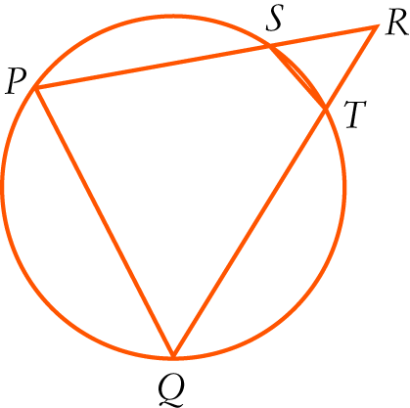

[5 marks]

